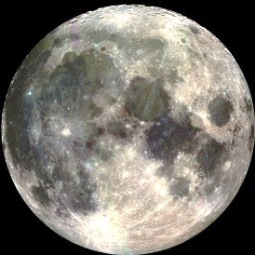
Lunar Eclipse
Student Learning Map
Name: _________
Date: _________

Vocabulary terms: Example:
lunar eclipse:

penumbral lunar eclipse:

partial lunar eclipse:

total lunar eclipse:

blood moon:

©MrJacksBackpack
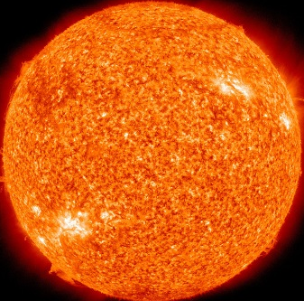
Solar Eclipse
Student Learning Map
Name: _________
Date: _________

Vocabulary terms: Example:
solar eclipse:

partial solar eclipse:

annular solar eclipse:

total solar eclipse:

hybrid solar eclipse:

Name: ____________
Eclipses - Review

Directions: Use this word bank to complete the sentences on this page about lunar and solar eclipses.

total eclipse penumbral eclipse partial eclipse lunar eclipse blood moon
new moon full moon eclipse annular eclipse hybrid eclipse

- When the Earth passes in front of the Moon, a _______________________ occurs.
- An _____________________ happens when the Moon is too far from Earth to completely cover the disk of the Sun.
- A ________________________ is very hard to notice because the Moon is only slightly dimmer than a full moon during this eclipse.
- A ____________________ is another word for a lunar eclipse with a reddish glow.
- When a celestial body’s light is not completely blocked out by another celestial body it is classified as a ________________________.
- A lunar eclipse can only happen during which moon phase? ___________________
- A solar eclipse can only happen during which moon phase? ___________________
- When the Sun’s light is completely blocked out by the disk of the Moon, and a portion of Earth is within the Moon’s shadow, it is classified as a ______________________.
9) When any celestial object is covered by the shadow of another celestial object in any way, it is called a solar or lunar __________________.
10) A _____________________ is an eclipse so rare that it only happens once every 160 years. The distance of the Moon from Earth causes a combination of an annular eclipse and a total eclipse of the Sun depending where you see the eclipse from Earth.
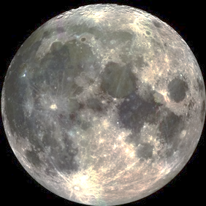
The Trip of a Lifetime
Name: __________
Persuasive Writing
8-12 sentences
Breaking News: N.A.S.A. has made a monumental announcement. They are choosing one student and teacher to go on their next trip to the Moon! Exactly one year from today you will be taking off from Kennedy Space Center towards the International Space Station. Two days later you will be leaving the International Space Station and taking the lunar lander to the surface of the Moon. In this paper, you will try to persuade N.A.S.A. to choose you and your teacher. Why would you like to be a part of this trip? What research might you conduct? What separates you from the other millions of children who would like to go on this trip of a lifetime?
______________________________________________________________________________________________________________________________________________________________________________________________________________________________________________________________________________________________________________________________________________________________________________________________________________________________________________________________________________________________________________________________________________________________________________________________________________________________________________________________________________________________________________________________________________________________________________________________________________________________________________________________________________________________________________________________________________________________________________________________________
____________________________________________________________________________________________________________________________________________________________________________________________________________________________________________________________________________________________________________________________________________________________________________________________________________________________________________________________________________________________________________________________________________________________________________________________________________________________________________________________________________________________________________________________________________________________________________________________________________________________________________________________________________________________________________________________________________________________________________________________________________________________________________________________________________________________________________________________________________________________________________________________________________________________________________________________________________________________________________________________________________________________________________________________________________________________________
____________________________________________________________________________________________
Name: ________________________ Date: _________________

Solar Eclipse & Lunar Eclipse
Assessment

 |  | Word Bank:
eclipse | lunar eclipse | solar eclipse | partial eclipse | total eclipse

Fill in the blank with the word that BEST answers the question.

- When the Moon passes into the shadow that is being cast by the Earth, a(n) _______________________ occurs.
- A(n) _________________________ is when only part of the Sun or the Moon is covered by a shadow, almost as if it looks like a cookie with a bite taken out of it.
- A(n) ________________________ is defined as an event in which a celestial body like a planet or a moon moves into the shadow of another celestial body which puts it into a giant shadow.
- When the Moon passes directly in front of the Sun from your position on Earth, a(n) ________________________ happens.
- If a celestial body like a planet or a moon is covered completely from receiving the Sun’s light, and the body is perfectly in line with the Sun, a(n) _____________________ occurs.

Choose the best letter for each true/false question. (Circle the best choice)

6) Being able to see a solar eclipse is more rare than seeing a lunar eclipse. T F
7) An eclipse occurs when an object is within another object’s shadow. T F
8) A solar eclipse can only happen during a full moon. T F

Label each shadow in the space below being made by Earth from the Sun’s light using the following three words: umbra, penumbra, antumbra.

(11)
(10)
(9)
Sun
Earth
(not to scale)
(11)

9) _____________________ 10) _____________________ 11) _____________________

Choose the best answer choice for each of the following multiple choice questions.

12) When the moon’s disk does not completely cover the Sun, that is known as a(n)
Sun
- lunar eclipse
Moon
- annular eclipse
- total eclipse
- penumbral eclipse
13) During a total solar eclipse, a flash of light shines from behind the Moon creating a brilliant natural wonder. This ring of light is known as the
- solar corona
- solar nebula
- solar disk
- solar panel
14) A lunar eclipse can only happen during which moon phase?
- new moon
- full moon
- first quarter
- third quarter
15) The most rare type of eclipse happens when the Moon’s distance is so finely balanced from Earth that depending on your position on Earth, you could see an annular eclipse or a total solar eclipse. This rare eclipse is called a(n)
- partial solar eclipse
- centurial solar eclipse
- penumbral solar eclipse
- hybrid solar eclipse
16) Which of the following describes a solar eclipse:
- the Moon passes perfectly in line with the Earth, and the Moon covers the Sun’s light
- Earth passes perfectly in line with the Moon, and Earth covers the Sun’s light
- when the full moon is on plane with the Earth’s orbit
- when the Moon reaches its apogee

Answer these questions in complete sentences.

17) Explain using detail what causes the Moon to have a reddish glow (blood moon) during a total lunar eclipse. _____________________________________________________________
_____________________________________________________________________________
____________________________________________________________________________
_____________________________________________________________________________
_____________________________________________________________________________
18) Explain the difference between a partial eclipse and a total eclipse _____________________________________________________________________________
_____________________________________________________________________________
_____________________________________________________________________________

